% in this programe a highly scattered enviroment is considered. The

% Capacity of a MIMO channel with nt transmit antenna and nr recieve

% antenna is analyzed. The power in parallel channel (after

% decomposition) is distributed as water-filling algorithm

% the pdf of the matrix lanada elements is depicted too.

clear all

close all

clc

% MIMO·¢ÉäÌìÏßºÍ½ÓÊÕÌìÏßµÄ¸öÊý

nt_V = [1 2 3 2 4];

nr_V = [1 2 2 3 4];

% ²ÎÊý

N0 = 1e-4;

B = 1;

Iteration = 1e4; % must be grater than 1e2

% ÐÅÔë±È(11¸öµã£©

SNR_V_db = [-10:3:20];%·Ö±´

SNR_V = 10.^(SNR_V_db/10);%·Ö±´×ª»»ÎªSNRµÄvalue

% 0.1000 0.1995 0.3981 0.7943 1.5849 3.1623 6.3096 12.5893 25.1189 50.1187 100.00

% ×÷Í¼ÑÕÉ«¼°±ê¼Ç

color = ['b';'r';'g';'k';'c'];

notation = ['-o';'->';'<-';'-^';'-s'];

%ºËÐÄ´úÂë£º´óÑ­»·

for(k = 1 : 5)

nt = nt_V(k);

nr = nr_V(k);

for(i = 1 : length(SNR_V))

Pt = N0 * SNR_V(i);

for(j = 1 : Iteration)

H = random('rayleigh',1,nr,nt);

[S V D] = svd(H);

landas(:,j) = diag(V);

[Capacity(i,j) PowerAllo] = WaterFilling_alg(Pt,landas(:,j),B,N0);

end

end

f1 = figure(1);

hold on

plot(SNR_V_db,mean(Capacity'),notation(k,:),'color',color(k,:))

f2 = figure(2);

hold on

[y,x] = hist(reshape(landas,[1,min(nt,nr)*Iteration]),100);

plot(x,y/Iteration,'color',color(k,:));

clear landas

end

f1 = figure(1)

legend_str = [];

for( i = 1 : length(nt_V))

legend_str =[ legend_str ;...

{['nt = ',num2str(nt_V(i)),' , nr = ',num2str(nr_V(i))]}];

end

legend(legend_str)

grid on

set(f1,'color',[1 1 1])

xlabel('SNR in dB')

ylabel('Capacity bits/s/Hz')

f2 = figure(2)

legend(legend_str)

grid on

set(f2,'color',[1 1 1])

ylabel('pdf of elements in matrix landa in svd decomposition of marix H')

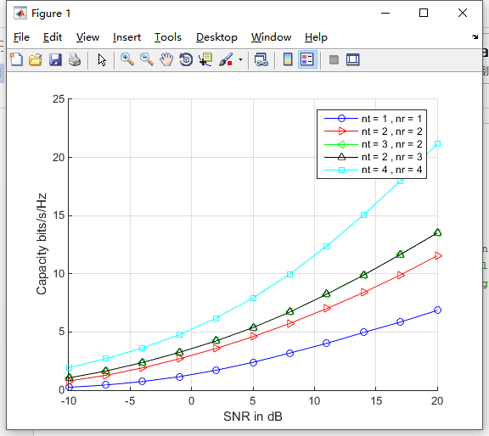

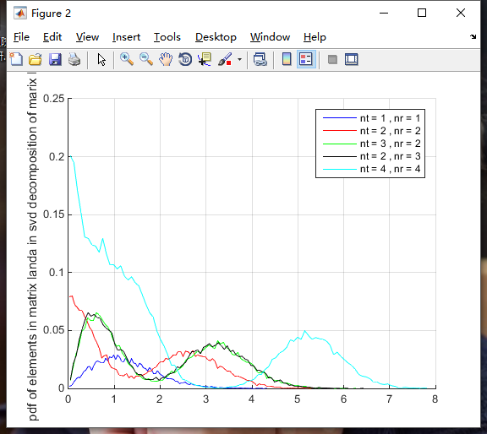

function [Capacity PowerAllo] = WaterFilling_alg(PtotA,ChA,B,N0);

%

% WaterFilling in Optimising the Capacity

%===============

% Initialization

%===============

ChA = ChA + eps;

NA = length(ChA); % the number of subchannels allocated to

H = ChA.^2/(B*N0); % the parameter relate to SNR in subchannels

% assign the power to subchannel

PowerAllo = (PtotA + sum(1./H))/NA - 1./H;

while(length(find(PowerAllo < 0 ))>0)

IndexN = find(PowerAllo <= 0 );

IndexP = find(PowerAllo > 0);

MP = length(IndexP);

PowerAllo(IndexN) = 0;

ChAT = ChA(IndexP);

HT = ChAT.^2/(B*N0);

PowerAlloT = (PtotA + sum(1./HT))/MP - 1./HT;

PowerAllo(IndexP) = PowerAlloT;

end

PowerAllo = PowerAllo.';

Capacity = sum(log2(1+ PowerAllo.' .* H));